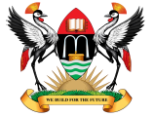

**MAKERERE**

**UNIVERSITY**

TRACEME - A Vehicle and Passenger Tracking & Monitoring System using GPS and GSM/GPRS

By

Group BSE 16-29

DEPARTMENT OF NETWORKS

SCHOOL OF COMPUTING AND INFORMATICS TECHNOLOGY

A Project SRS submitted to the School of Computing and Informatics Technology

in Partial Fulfillment of the

Requirements for the Award of the Degree of Bachelor of Science in Software Engineering Of Makerere University.

December 2015